Number Hashing:

1. Given an array and asked to find find how many times particular number appears

[1,2,4,3,1,5,3]

how many time 3 appears?

it will take O(N) time as you iterate through array for 3 and maintain count variable. Now if we increasethe numbers we want to find. Lets say I am asking to find Q numbers.

Then total TC will be QN which is not good.

Alternative -> Hashing

[1,2,4,3,1,5,3]-----------iterate through array once and pre compute if you know what max limit you can have. Let's say here we can have till 10 then array will b of size 11

Prefill all value as 0 --> [0,0,0,0,0,0,0,0,0,0,0]

and then iterate through given array and keep increasing the count in new array for respective index.

[ 0 , 0 , 0 ,0 ,0 ,0 ,0 ,0 ,0 ,0 , 0 ] ----------->

0, 1 2 3 4 5 6 7 8 9 10

[ 0 , 2 , 1 ,2 ,1 ,1 ,0 ,0 ,0 ,0 , 0 ] -----> Now to find how many times 3 appear, you just ha to fetch that index from newArr(newArr[3]), which will be o(1).

0, 1 2 3 4 5 6 7 8 9 10

Reducing initial TC from Q\*O(N) to Q\*O(1).

This is called ARRAY HASHING

Character Hashing:

2. If given character array, then what will you do as index in new Array will be integer---> then you can take their ASCII values

[a, d, c, a, f, d] -------> [2, 0, 1, 2, 0, 2]

a, b, c, d, e, f

As 'a' = 97-----> index = 'a'-'a' = 0

'd' = 100 -----> index = 'd'-'a' = 3

what if array can have othere characters also like A, 7 ----> the take new Array of size 256 as there ara only 256 character in ASCII and you can assign and increment values directly

instead of calculating their index position.

BONUS INFO:

Max size of integer array that can be initialized ---> 10^8 in Java

Now this is an isssue as size > 10^8 you can not cope, then comes collection to solve this problem -----> HashMap

Key == Number , Value == Frequency

[1, 2, 4, 1, 2, 12]

Map:

[{1, 2}

{2, 2}

{4, 1}

{12, 1}]

That's it, now if you see if you will be solving above prob with array you will need 13 size array as max value is 12, but in map you only save 4 values. That's it.

Now, when you want to use Map in char array, you can directly use it as <Character, Integer>

Storing or fetching from map in all best, average and worst cases takes logN TC.

How Map is able to do this work:

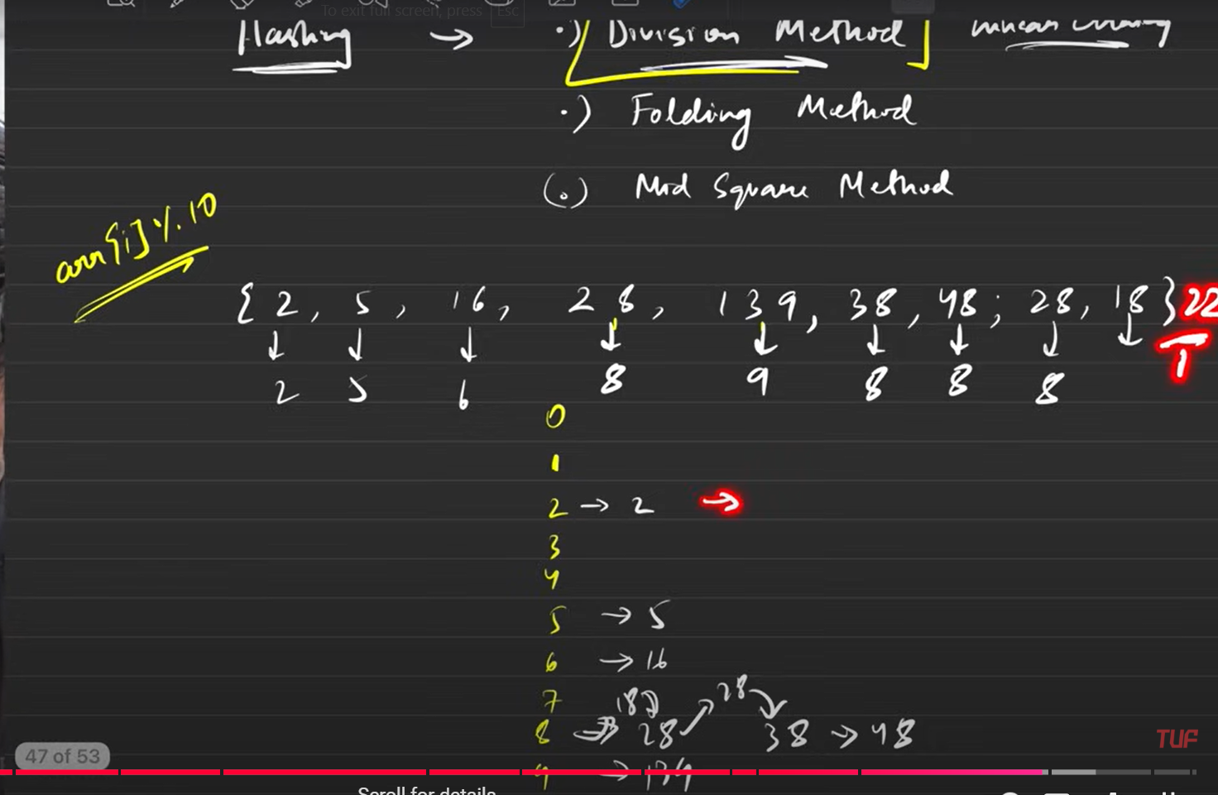

By doing modulo and chaining for same modulos.

Video link: https://www.youtube.com/watch?v=KEs5UyBJ39g&t=2032s